##### A Project report on

**PATIENT STABILITY PREDICTION USING MACHINE LEARNING**

###### A Dissertation submitted to JNTU Hyderabad in partial fulfillment of the academic requirements for the award of the degree.

**Bachelor of Technology**

**in**

**Computer Science and Engineering**

Submitted by

**G. ARCHITH KUMAR**

(19H51A05D5)

**MOHD IFTEQUARUDDIN**

(19H51A05E0)

**R. ROHITH REDDY**

(19H51A05E8)

Under the esteemed guidance

Of

**MAJOR Dr. V.A. NARAYANA**

(PROFESSOR, PRINCIPAL)



**Department of Computer Science and Engineering**

**CMR COLLEGE OF ENGINEERING & TECHNOLOGY**

(An Autonomous Institution under UGC & JNTUH, Approved by AICTE, Permanently Affiliated to JNTUH, Accredited by NBA.)

KANDLAKOYA, MEDCHAL ROAD, HYDERABAD - 501401.

#### 2019- 2023

**CMR COLLEGE OF ENGINEERING & TECHNOLOGY**

KANDLAKOYA, MEDCHAL ROAD, HYDERABAD – 501401

**DEPARTMENT OF COMPUTER SCIENCE AND ENGINEERING**



#### CERTIFICATE

This is to certify that the Major Project Phase-1 report entitled **"PATIENT STABILITY PREDICTION USING MACHINE LEARNING"** being submitted by **G. ARCHITH KUMAR (19H51A05D5)**, **MOHD IFTEQUARUDDIN (19H51A05E0)**, **R. ROHITH REDDY (19H51A05E8)** in partial fulfillment for the award of **Bachelor of Technology in Computer Science and Engineering** is a record of bonafide work carried out his/her under my guidance and supervision.

###### The results embodies in this project report have not been submitted to any other University or Institute for the award of any Degree.

**Dr. SIVA SKANDHA SANAGALA**

**-ASSOCIATE PROFESSOR, HOD**

**Dept. of CSE**

**MAJOR Dr. V.A. NARAYANA**

**-PROFESSOR, PRINCIPAL**

**Dept. of CSE**

#### ACKNOWLEDGEMENT

With great pleasure we want to take this opportunity to express my heartfelt gratitude to all the people who helped in making this project work a grand success.

We are grateful to **Dr. V A Narayana,** Principal, Department of Computer Science and Engineering for his valuable technical suggestions and guidance during the execution of this project work.

We would like to thank **Dr. Siva Skandha Sanagala,** Head of the Department of Computer Science and Engineering, CMR College of Engineering and Technology, who is the major driving forces to complete my project work successfully.

We are very grateful to **Dr. Vijaya Kumar Koppula**, Dean-Academic, CMR College of Engineering and Technology, for his constant support and motivation in carrying out the project work successfully.

We are highly indebted to **Dr. V A Narayana,** Principal, CMR College of Engineering and Technology, for giving permission to carry out this project in a successful and fruitful way.

We would like to thank the Teaching & Non- teaching staff of Department of Computer Science and Engineering for their co-operation

We express our sincere thanks to **Mr. Ch. Gopal Reddy**, Secretary, CMR Group of Institutions, for his continuous care.

Finally, we extend thanks to our parents who stood behind us at different stages of this Project. We sincerely acknowledge and thank all those who gave support directly and indirectly in completion of this project work.

G. ARCHITH KUMAR (19H51A05D5)

MOHD IFTEQUARUDDIN (19H51A05E0)

R. ROHITH REDDY (19H51A05E8)

PATIENT STABILITY PREDICTION USING MACHINE LEARNING

**TABLE OF CONTENTS**

**CHAPTER**

**NO. TITLE PAGE NO.**

LIST OF FIGURES ii

LIST OF TABLES iii

ABSTRACT iv

**1** **INTRODUCTION** 1

1.1 Problem Statement 2

1.2 Research Objective 2

1.3 The Main Algorithms Of Machine Learning 3-4

**2** **BACKGROUND WORK** 5

2.1. Liver Segmentation From CT Images 6

2.1.1.Introduction 6

2.1.2.Merits,Demerits and Challenges 6

2.1.3.Implementation of 7

Liver Segmentation From CT Images

2.2. Automatic Detection Of Cerebral Microbleeds From MR Images 8

2.2.1.Introduction 8

2.2.2.Merits,Demerits and Challenges 8

2.2.3.Implementation of Automatic 9

Detection Of Cerebral Microbleeds From MR Images

**3 RESULTS AND DISCUSSION** 10 3.1. Comparison of Existing Solutions 11

3.2. Data Collection and Performance metrics 11-12

**4** **CONCLUSION** 13

4.1 Conclusion 14

**5** **REFERENCES** 15-16

CMRCET B. Tech (CSE) Page No i

PATIENT STABILITY PREDICTION USING MACHINE LEARNING

**List of Figures**

**FIGURE**

**NO. TITLE PAGE NO.**

1.2.1 Traditional And New Model Of Medical Care 3

1.3.1 ANN Model 4

1.3.2 SVM Model 4

2.1.3.1 Segmentation results 7

2.2.3.1 Overview Diagram 9

3.2.1 Data Collection 11

3.2.2 Implementation Of Proposed Method 12

CMRCET B. Tech (CSE) Page No ii

PATIENT STABILITY PREDICTION USING MACHINE LEARNING

**List of Tables**

**FIGURE**

**NO. TITLE PAGE NO.**

3.1.1 Comparison Of Existing Solutions 11

3.2.3 Comparison Of Existing And Proposed Solutions 12

CMRCET B. Tech (CSE) Page No iii

PATIENT STABILITY PREDICTION USING MACHINE LEARNING

# **ABSTRACT**

These years, with artificial intelligence and machine learning becoming the hotspot of research, several applications have emerged in each of these areas. It exists not only as a kind of academic frontier but also something close to our life. In this trend, the combination of medical care and machine learning becomes more and more tighter. The proposal of its main idea also greatly alleviated the existing situation of unbalanced medical distribution and resources strain. This paper summarizes some application of machine learning and auxiliary tumor treatment in the process of medical resource allocation, and puts forward some new methods of application to realize it closer to human life in the era of artificial intelligence and the explores a good situation of mutual combination of medical industry and computer industry, which is benefit both.

CMRCET B. Tech (CSE) Page No iv

PATIENT STABILITY PREDICTION USING MACHINE LEARNING

# **CHAPTER 1**

**INTRODUCTION**

CMRCET B. Tech (CSE) Page No 1

PATIENT STABILITY PREDICTION USING MACHINE LEARNING

**CHAPTER 1**

**INTRODUCTION**

* 1. **PROBLEM STATEMENT:**
* In the medical image analysis, although the error caused by the subjective condition of the doctor is avoided, it is also limited by the objective conditions, such as noises, and other errors are still easy to occur.
* The current research has made achievements in pathological analysis, but it is still not applicable to the illness requiring human resources, such as analgesia and fever, which are more common.
* Although machine learning has already invested in many researches and applications in assisting tumor treatment, it still requires more financial and personnel requirements to make relevant research and development and to put into large-scale use.
  1. **RESEARCH OBJECTIVE:**
* The adoption of the machine learning method means that simple work can be directly replaced by machines. It means that, at the same time, the employment situation of the relevant personnel and the education level of the medical profession need to be improved.
* If we want to make sure that the patient's condition is as correct as possible, you must first ensure that we have a database that covers as much relevant information as possible, create a target data set, and then preprocess it (this process may cost 60 About % of the energy), and then through the data conversion to find useful data features, and then data mining.

CMRCET B. Tech (CSE) Page No 2

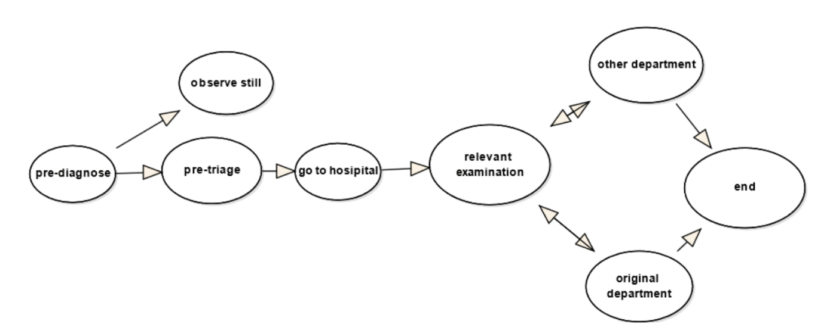 PATIENT STABILITY PREDICTION USING MACHINE LEARNING

**Fig. 1.2.1 - Traditional And New Model Of Medical Care**

* 1. **THE MAIN ALGORITHM OF MACHINE LEARNING:**

1. **Decision Tree Based Methods**

The algorithm of decision tree is a method, which creates a decision tree by existing data and inputs the training set. According to the growth direction of decision tree, the test data can be classified. The main idea of decision tree is which feature is the best, how many branches can be generated and the time when to stop splitting. During this procession, it can be determined by the variable which is called impurity and some other mathematical method. However, due to the fact that it is a greedy approach, decision tree may disable to find the best tree sometimes.

1. **Naïve Bayes And Bayesian Belief Networks**

Naïve Bayes is a ML method based on probability theory. It assumes that vents are independent and calculates through prior probability and posterior probability of the target object. The formula is as follows.

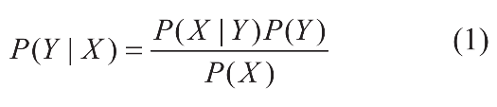

Because this principle of this method is relatively simple, and the prediction efficiency is high although, the conditions 177 are strict, it is still widely used in the field of natural language recognition and so on.

1. **K-means**

In this method, the variable k is chosen by the actual situation. After choosing k

objects as the primary center of clusters randomly, it calculates the distance between

every object and the center of clusters and then assigns the object into the closest

CMRCET B. Tech (CSE) Page No 3

PATIENT STABILITY PREDICTION USING MACHINE LEARNING

cluster. Until all objects have been assigned, the centroid of every cluster will be calculated again. The process will be repeated until the centroid doesn’t change. The algorithm is an iterative and programming is less difficult.

1. **Artificial Neural Network (ANN)**

Artificial Neural Network (ANN) is an algorithm that imitates the learning process of human brain, consisting of many nodes which is called neurons connected to each other. Each node represents a special function called activation function. There is a value of weight between two nodes. As a kind of computing model, neural network is divided into forward network and feedback network. Through the input of training set the neural network is trained and different weight values are modified, the nonlinear data will be processed to achieve the purpose of learning.

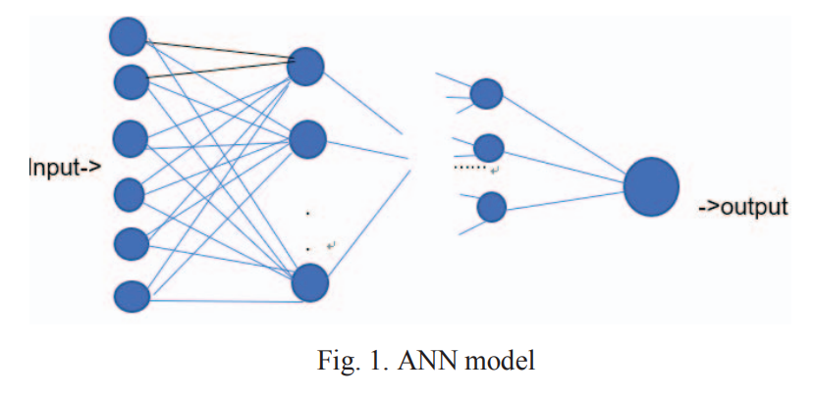

**Fig. 1.3.1 ANN model**

1. **Support Vector Machine (SVM)**

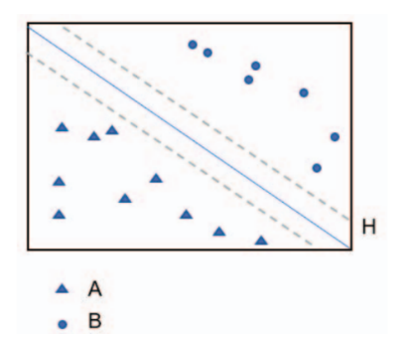SVM is an important part of statistical learning theory, which by transforming input space into high-dimensional space. In the linear classification, the hyperplane and loss function are constructed to solve the minimum of the loss of agent; for the linear indivisible problem, the method can be applied and the method is used to segment the hypersurface with feature space. SVM is often used in the analysis of medical conditions and the judgement of benign and malignant tumors, but it is difficult to implement in largescale training samples because it may involve the calculation of high-order matrices.

**Fig. 1.3.2 SVM model**

CMRCET B. Tech (CSE) Page No 4

PATIENT STABILITY PREDICTION USING MACHINE LEARNING

**CHAPTER 2**

**BACKGROUND WORK**

CMRCET B. Tech (CSE) Page No 5

PATIENT STABILITY PREDICTION USING MACHINE LEARNING

**CHAPTER 2**

**BACKGROUND WORK**

**2.1 Liver Segmentation From CT Images Using A Sparse Priori Statistical Shape Model (SP-SSM)**

**2.1.1 INTRODUCTION:**

**AUTHORS**: **Xuehu Wang , Yongchang Zheng ,Lan Gan, Xuan Wang, Xinting Sang, Xiangfeng Kong, Jie Zhao**

This study proposes a new liver segmentation method based on a sparse a priori statistical shape model (SP-SSM). First, mark points are selected in the liver a priori model and the original image. Then, the a priori shape and its mark points are used to obtain a dictionary for the liver boundary information. Second, the sparse coefficient is calculated based on the correspondence between mark points in the original image and those in the a priori model, and then the sparse statistical model is established by combining the sparse coefficients and the dictionary. Finally, the intensity energy and boundary energy models are built based on the intensity information and the specific boundary information of the original image. Then, the sparse matching constraint model is established based on the sparse coding theory. The SP-SSM can achieve a mean overlap error of 4.8% and a mean volume difference of 1.8%, whereas the average symmetric surface distance and the root mean square symmetric surface distance can reach 0.8 mm and 1.4 mm, respectively.

**2.1.2 MERITS, DEMERITS AND CHALLENGES:**

**MERITS:**

* This new liver segmentation method achieving at some level in medical field.

**DEMERITS:**

* Can achieve a mean overlap error of 4.8%.
* Time taking process.

**CHALLENGES:**

* One should over come the mean overlap error and Time-consuming process.
* And there are some un predictable results one should overcome that.

CMRCET B. Tech (CSE) Page No 6

PATIENT STABILITY PREDICTION USING MACHINE LEARNING

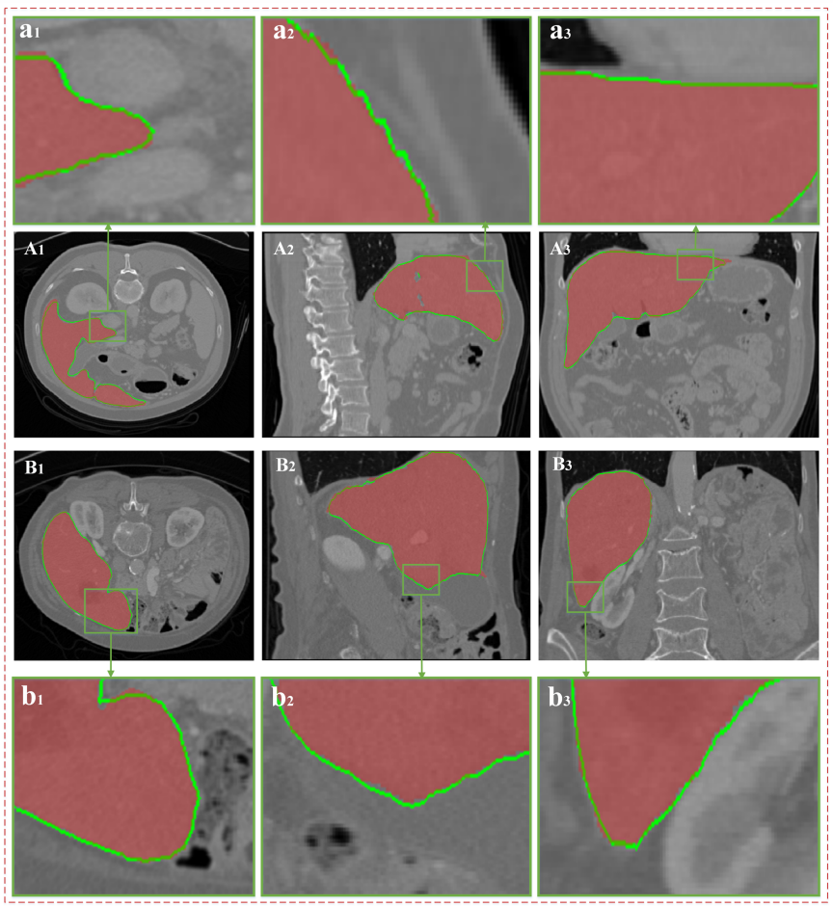**2.1.3. IMPLEMENTATION**

**Fig. 2.1.3.1 - Segmentation Results**.

(A) and (B) show the two groups of CT data; (A1), (A2) and (A3) express the same groups of data on the cross section, vertical plane, and coronal plane, respectively; and (a1), (a2) and (a3) show the partially enlarged images corresponding to the green areas in (A1), (A2) and (A3), respectively. The red area in every image indicates the real liver boundaries, and the green line indicates the liver segmentation results based on the proposed algorithm.

CMRCET B. Tech (CSE) Page No 7

PATIENT STABILITY PREDICTION USING MACHINE LEARNING

**2.2 Automatic Detection Of Cerebral Microbleeds From MR Images Via 3D Convolutional Neural Networks**

**2.2.1 INTRODUCTION:**

**AUTHORS: Qin Yu, Tao Jiang, Aiyun Zhou, Lili Zhang, Cheng Zhang & Pan Xu**

Cerebral microbleeds (CMBs) are small haemorrhages nearby blood vessels. They have been recognized as important diagnostic biomarkers for many cerebrovascular diseases and cognitive dysfunctions. Compared with previous methods that employed either low-level hand-crafted descriptors or 2D CNNs, our method can take full advantage of spatial contextual information in MR volumes to extract more representative high-level features for CMBs, and hence achieve a much better detection accuracy. To further improve the detection performance while reducing the computational cost, we propose a cascaded framework under 3D CNNs for the task of CMB detection. We first exploit a 3D fully convolutional network (FCN) strategy to retrieve the candidates with high probabilities of being CMBs, and then apply a well-trained 3D CNN discrimination model to distinguish CMBs from hard mimics. Compared with traditional sliding window strategy, the proposed 3D FCN strategy can remove massive redundant computations and dramatically speed up the detection process. We constructed a large dataset with 320 volumetric MR scans and performed extensive experiments to validate the proposed method, which achieved a high sensitivity of 93.16% with an average number of 2.74 false positives per subject, outperforming previous methods using low-level descriptors or 2D CNNs by a significant margin.

**2.2.2 MERITS, DEMERITS AND CHALLENGES:**

**MERITS:**

* This Automatic detection method achieving at some level in medical field.

**DEMERITS:**

* This procedure is laborious, time-consuming, high cost and error prone.

**CHALLENGES:**

* One should overcome Time-consuming process problem and reduce the cost.
* And the procedure also little complicated.

CMRCET B. Tech (CSE) Page No 8

PATIENT STABILITY PREDICTION USING MACHINE LEARNING

**2.2.3. IMPLEMENTATION**

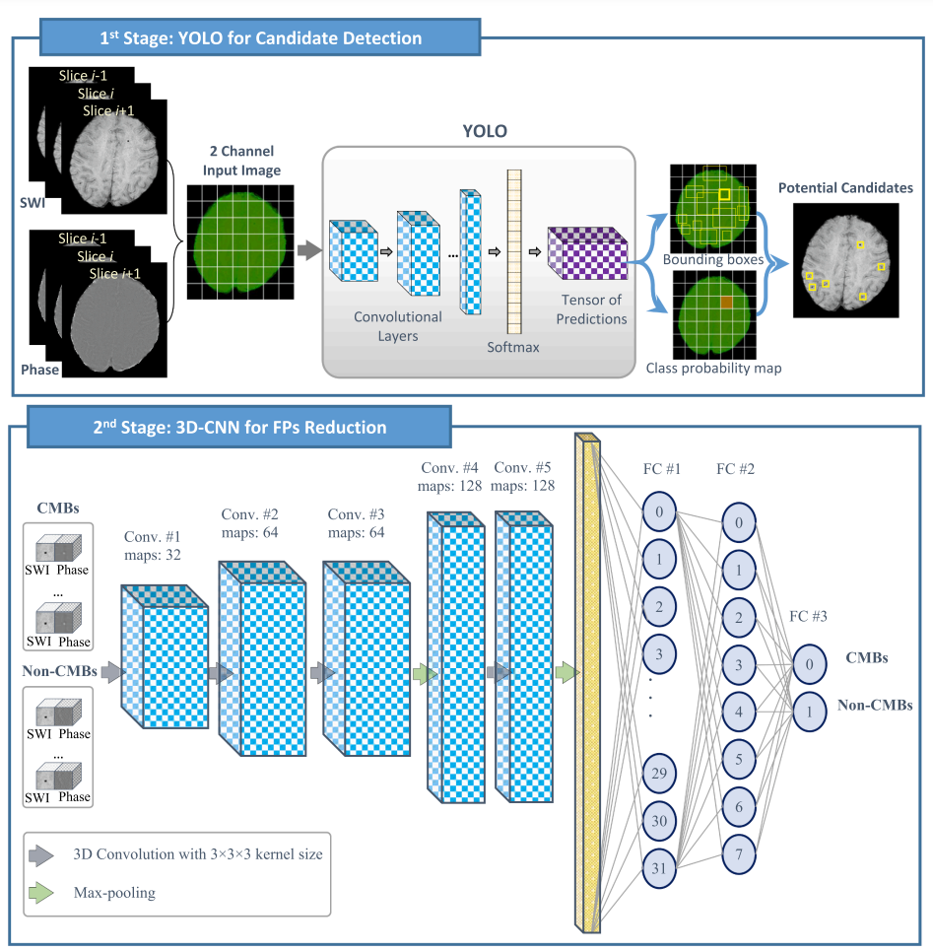

**Fig. 2.2.3.1 - Overview Diagram Of The Two-Stage Deep Learning Approach.**

CMRCET B. Tech (CSE) Page No 9

PATIENT STABILITY PREDICTION USING MACHINE LEARNING

**CHAPTER 3**

**RESULTS AND DISCUSSION**

CMRCET B. Tech (CSE) Page No 10

PATIENT STABILITY PREDICTION USING MACHINE LEARNING

**CHAPTER 3**

**RESULTS AND DISCUSSION**

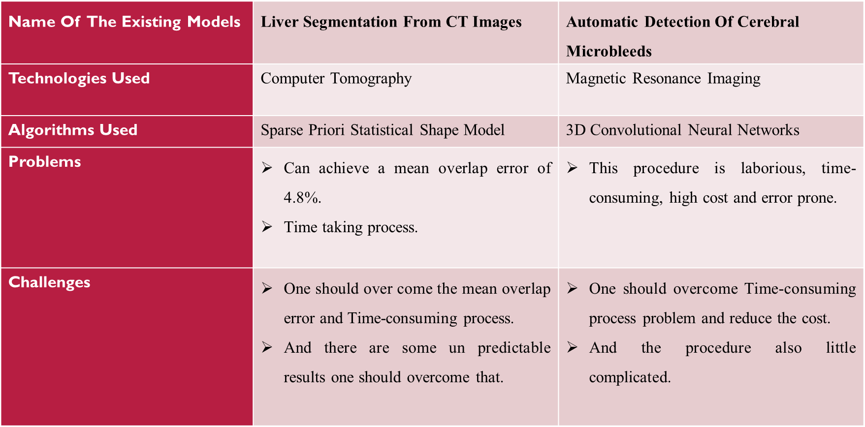**3.1 COMPARISON OF EXISTING SOLUTIONS**

**Table 3.1.1 - Comparison Of Existing Solutions**

**3.2. DATA COLLECTION AND PERFORMANCE METRICS**

* 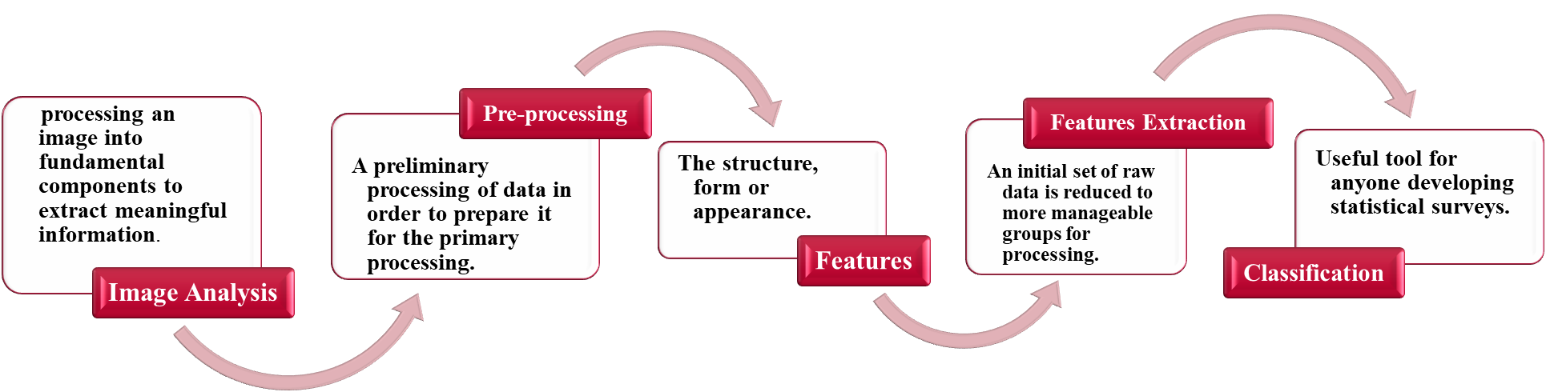The data will be taken in the form of datasets and using that datasets the algorithms are performed.

**Fig. 3.2.1 – Data Collection**

CMRCET B. Tech (CSE) Page No 11

PATIENT STABILITY PREDICTION USING MACHINE LEARNING

**METRICS STUDY:**

* Medical Equipment Utilization.
* Patient Drug Cost Per Stay.
* Treatment Costs.
* Operating Cash Flow.

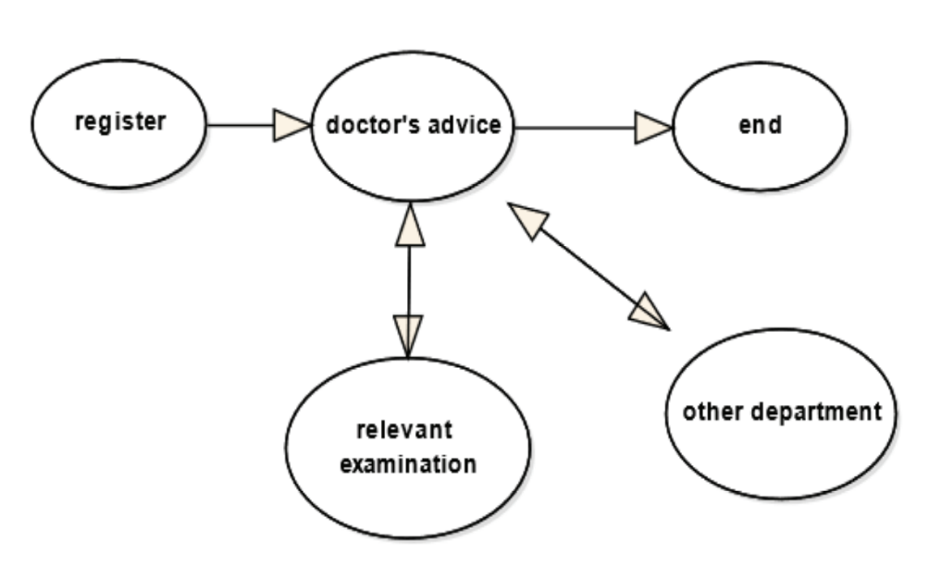

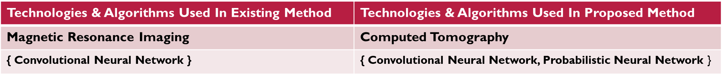 **Fig. 3.2.2 - Implementation Of Proposed Method**

**Table 3.2.3 - Comparison Of Existing And Proposed Solutions**

CMRCET B. Tech (CSE) Page No 12

PATIENT STABILITY PREDICTION USING MACHINE LEARNING

CHAPTER 4

**CONCLUSION**

CMRCET B. Tech (CSE) Page No 13

PATIENT STABILITY PREDICTION USING MACHINE LEARNING

**CHAPTER 4**

**4.1 CONCLUSION**

These reviews the main methods of machine learning, and summarizes several representative applications after understanding the history of machine learning in the medical field and its current application. The typical ideas and algorithms are summarized. At the same time, the improvement method based on machine learning in the process of visiting is proposed. However, this does not mean that ML is perfect. Whether in terms of technology, ethic or law, it has certain problems. The solution of these problems requires technicians and legal personnel. Working together, and how to strike a balance between manpower and machine is also a problem that everyone of us must face.

CMRCET B. Tech (CSE) Page No 14

PATIENT STABILITY PREDICTION USING MACHINE LEARNING

**CHAPTER 5**

**REFERENCES**

CMRCET B. Tech (CSE) Page No 15

PATIENT STABILITY PREDICTION USING MACHINE LEARNING

**CHAPTER 5**

## REFERENCES

[1] Jiang M, Zhang S, Huang J, et al. Scalable histopathological image analysis via supervised hashing with multiple features[J]. Medical Image Analysis, 2016, 34:3-12.

[2] Joanna J K, Pawel K . Automatic Classification of Specific Melanocytic Lesions Using Artificial Intelligence[J]. BioMed Research International, 2016, 2016:1-17.

[3] Lu-Cheng, Zhu,Yun-Liang, Ye,Wen-Hua, Luo,Meng, Su,Hang-Ping, Wei,Xue-Bang, Zhang,Juan, Wei,Chang-Lin, Zou.A model to discriminate malignant from benign thyroid nodules using artificial neural network.[J].PloS one,2013,8(12):e82211.

[4] Huang W C , Chang C P . Automatic Nasal Tumor Detection by grey prediction and Fuzzy C-Means clustering[C]// IEEE International Conference on Systems. IEEE, 2006.M. Young, The Technical Writer’s Handbook. Mill Valley, CA: University Science, 1989.

[5] Sarraf S , Tofighi G . Classification of Alzheimer's Disease using fMRI Data and Deep Learning Convolutional Neural Networks[J]. 2016.

[6] Dou Q , Chen H , Yu L , et al. Automatic Detection of Cerebral Microbleeds from MR Images via 3D Convolutional Neural Networks[J]. IEEE Transactions on Medical Imaging, 2016:1-1.

[7] Pang-ning Tan, Michael Steinbach, Vipin Kumar, Introduction to data mining, Beijing: Posts & Telecom Press, 2011.

[8] Xue-Hu WANG, Study Liver Segmtation Method from CT Images based on Deformation Optimization and Sparse Statistics[D]. Beijing Institute of Technology, 2015.

[9] Yu Q , Jiang T , Zhou A , et al. Computer-aided diagnosis of malignant or benign thyroid nodes based on ultrasound images[J]. European Archives of Oto-Rhino-Laryngology, 2017, 274(7):2891- 2897.

[10] Fei Liu, Jun-Ran Zhang, Hao Yang. Advances in medical images recoginition based on deep learning[J]. Chinese Journal of Biomedical Engineering, 2018.

[11] Ke-Yang Zhao, Mu-Yue Yang, Jing-Yu Zhu, Ze-Qi Wang, Wei-Wei Shen. Machine learning AIDS in tumor dignosis[J]. Tumor, 2018, 38(10): 987-991.

[12] Bin Huang, Feng Liao, Yu-Feng Ye. Advances in machine learning in image analysis of nasopharyngeal carcinom[J]. International Journal of Medical Radiology, 2019(1).

CMRCET B. Tech (CSE) Page No 16